File Creation:

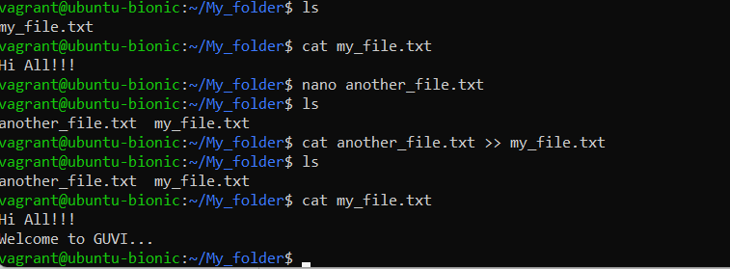

Multiple file creation:

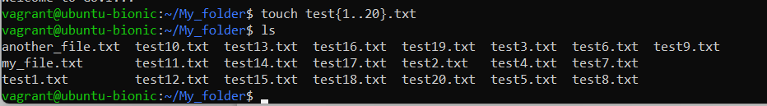

Rename 1st fine files to .yml:

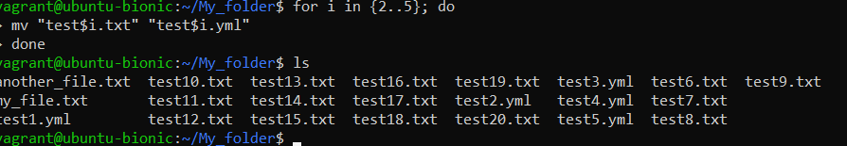

Print the latest created top 5 files among the total no of files:

